**Equity Investment Credit Union Project Report**

1. **Formalized Proposal**

Equity Investment Credit Union is a small bank operating in the rural community of Oskaloosa, Iowa City in the state of Iowa and their main customers are the Amish community. Amish use banks often to handle everything from making deposits to taking out business loans and mortgages. Amish often live near small towns, giving them access to local bank in their community. This bank project proposal is to come up with a bank management system that can handle teller daily activities within one screen. This mainly includes creating new account, deposit, and withdrawal for both checking and saving accounts, check account balance, run end of day process that will show account balances that had transaction within that day. This is interface which will be integrated to the main banking system which has more modules. This interface with only be used by the bank tellers to make their daily activities simpler and faster.

* 1. **Introductory paragraph describing your project from generic to specific**

With current system, tellers have access to a lot of customer information at hand which they do not require, and they must navigate through different module to do a simple customer deposit or withdrawal. This led to the proposal to design this interface module solely to be used by bank tellers. The main objective of this project was to come up with a single user module that will enable a teller, open a new account, deposit, or withdraw and check account balances. At the end of the shift the teller should run a report that will show all the accounts that had deposits or withdrawal within that day.

The teller should be able to search for an account and based on the search, the system should display the account detail if it exists or display an output message the account does not exit. Base on the search the teller should now be able to deposit, withdraw or check account balance as per customer request. If the account does not exit, then a new account should be open by the teller.

* 1. **Paragraph(s) describing your project**

The project main objectives are to enable bank tellers at equity investment credit union to be able to handle the following tasks during the shift:

* Customer deposits
* Customer withdrawal
* Check customer balances as requested
* Create new account
* End of day report.

How the system will operator is once the tellers log in to the application, they will have access to one screen which will enable them handle deposits, withdrawals, balance check, create new account as well as run the end of process and report.

At the point of serving each customer, the teller will have two textboxes to enter the account number and the amount. The account textbox will search if the account exits or not. If the account exists, they can proceed to enter the amount in the amount textbox depending whether it is a deposit, or withdrawal. For account balance inquiry, enter the account number, check on balance radio button then click execute. If the account does not exist, internal bank processes will be followed before opening a new account.

At the end of shift, the teller will run the end of day process by clicking end on day button. The purpose of this process to reconcile account balances for each account that had deposit or withdrawal during the day is and making sure the balances are accurate. The bank has its own internal process to check opening balances for each account that has a transaction against the closing balance and transaction. At some point each teller with reconcile physical deposit or withdrawal receipts against the account activity for the day.

The design of the system is not web based because all the teller transactions are done at the banking hall and bank does do not have any other branches at the moment. In future there is a proposal to convert this system to an online application.

1. **Time/Change Logs**
   1. **If you kept daily or change logs**

My project logs ranges from March 3rd, 2020 to April 3rd ,2020 approximately one month.

* 1. **Paragraphs describing a time quantum (day/week) and what you accomplished**

*March 3rd, 2020*

On this day I drafted my project proposal and below is the detailed report on the proposal.

**Project proposal**

1. ***Problem diagnosis:***

Equity Investment Credit Union tellers proposed a simpler interface to manage their daily operation which included check customer account balance, make deposit and withdrawal within one screen. Right now they are navigate through different module during their operations and this at times can be time consuming. They proposed for a simple interface which can perform all their operation within one screen. The interface should be linked to the overall bank application.

1. ***Proposed solution***

The proposed solution is to design an interface module that can enquire account balance, deposit, withdraw, create new account and run end of day report with all this features in one screen using Java as the preferred language.

1. ***Work Plan***

Below is the work plan to for the proposed design of the interface.

* Gather user requirements – 1 week approximately.
* Design and coding – 2 1/2 weeks.
* Testing - 3days.
* Final project ready for implementation.

*March 4th, 2020*

* On this day, I mostly did research on different existing application and how they work, and my main focus was on library management system which was my main project before switching to a bank management system.

*March 5Th, 2020*

* Researched on different data structures and how they are implemented. Most of my research was on YouTube as well as on google. I spend *3 hours* researching.

*March 6Th, 2020*

* Researched on different data structures and how they are implemented. Most of my research was on YouTube as well as on google. Spend *2 hours* researching.

March 7Th ,2020

* Designed a road map in terms of the classes I need and how they will be connected to each other. This was more of a pseudocode and not in detailed. Spend 4 hours in this.

March 8th ,2020

* Based on the functionality of the application I was not sure which data structure to use. Spend 3 hours researching on the best data structure to use.

March 9Th 2020

* Spend 2 hours researching on linked list, arrays, and hash maps.

March 10Th 2020

* As I was researching on the data structure, I came across an article how to use hash maps. This was very appealing and interesting to me. The idea of using hash map in a banking management system truck my mind. I spend 4 hours on this research.

March 11Th ,2020

* Researched more on banking systems mainly on the functionality and not paying attention to the language used. Spend 1 hour on this.

March 12Th ,2020

* Designed a pseudocode to give me a clear picture on how I wanted the application to work. Spend 3 hours on this.

March 13Th 2020

* Re-designed my pseudocode to meet a goal and outcome. Spend 3 hours on this.

March 14th ,2020

* This week I switched my project from a library management system to a bank management system as it seems easier to implement.
* The main reason I switched from a library management system to a bank management system is because I was still not sure how to implement my data structures in the library management system while as in bank system I strategy was clear on how I wanted to use Linked List and Hash Map data structures. Also, there were other students in the class who were undertaking a similar project and I wanted one of my own.

March 15Th ,2020

* With a clear picture on how I wanted the system to work in my mind it was time to document everything. I designed my pseudocode and sketched data flow diagram of how the system will work. This took me 3 hours.

March 16Th ,2020

* Jumped straight to Java eclipse and designed my three main classes. For a starter and testing I did a console application to see the results I wanted. I spent 4 hours on this.

March 17Th ,2020

* I made modification to my classed to incorporate the concept on object-oriented programming that is inheritance and abstraction. I spend 3 hours on this on this day.

March 18Th ,2020

* I tested my console output and I was impressed with the results. Now it was time to start designing my GUI and do away with console application. For this I spent 1 hour 30 mins.

March 19Th ,2020

* I designed most of the GUI features I would need. I also declared my linked list to the account class and few main panel designs. Spent 5 hours on this.

*March 20Th ,2020*

* Continued with the panel design and buttons design if even then where not working. Spent 5 hours on this.

*March 21st ,2020*

* Designed add action listener for the textboxes, checkboxes and two buttons. Spent 2 hours on this.

*March 22nd ,2020*

* Continued with action listener development and rest of the buttons. Spend 5 hours on this.

*March 23Rd ,2020*

* Tested if my action listeners where working as intended but doing researching to fix the bugs I was getting. spend 6 hours on this*.*

*March 24Th ,2020*

* 95 % of my buttons working as expected and continued testing as I fix system errors and functionality. Spend 4 hours on this.

*March 25Th ,2020*

* Testing system functionality and researched how to fix bugs. Spend 3 hours on this.

*March 26Th ,2020*

* Spend 2 hours preparing for my project power point presentation and recording how the system works. I also fixed minor system functionality.

*March 27Th ,2020*

* Final power point presentation preparing and presentation to the rest of the class. Spend 2 hours on this.

*March 28Th ,2020*

* Code cleanup and code comments for clarity. Spend 3 hours.

*March 29Th ,2020*

* Final project document preparation. Spend 2 hours.

*March 30Th ,2020*

* Final project document preparation. Spend 2 hours.

*May 1ST, 2020*

* Final project document preparation. Spend 2 hours.

*May 2ND ,2020*

* Final project document preparation. Spend 2 hours.

May 3RD ,2020

* Final project document preparation. Spend 2 hours.

1. **Lessons Learned**
   1. ***Talk about the scope of your project and if it changed.***

Initially, my proposed project was a library management system which was to manage, and record issued and return books in school library. Overall, the project was being developed to help the students as well as staff of library to maintain the library in the best way possible and reduce the human efforts.

Admin, the user had the capability to generate different kinds of reports like lists of students registered, list of books, issue, and return.

* 1. ***What blockers you encountered and the solutions you found***

My main blocker during the entire project is suitable time to accomplish each day’s milestone. On February 24th I was blessed with a baby boy named Nathan. As I begun my project, he was only one week old, I had to help my wife as she recuperated, take care of my two-year-old daughter (Samantha) and I have a full-time job. It was not easy but with well planned time management I was able to handle all.

I came up with timetable to woke up at 4am before everybody wakes up and do my assignments and this project. Each day I made sure at least I spend 2 hours minimum on the project.

The rest of the obstacle were errors in the code which with google and you tube help I was able to get solution.

1. **CODE including comments**
   1. A link to your GitHub repo (.java files on GitHub that include comments and Javadoc)

<https://github.com/pnthairu/MyProfile/upload/master/DataStructure>

1. **User's Manual**
   1. Explain how to run and interact with your program.

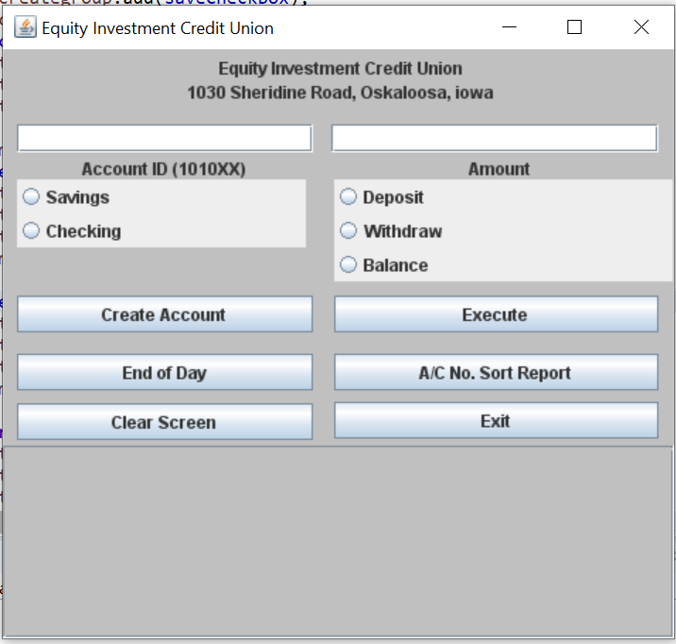

Bank teller must enter account number and amount in the account id and amount textboxes provided to proceed with the process of deposit or withdraw. The system will search if the account id exists and if it does not exist, a message will be displayed “account does not exit” else proceed to the next step of either to deposit, withdraw or check balance.

By default, the teller does not need to check if the account is a saving or checking. Depending whether it is a deposit or withdrawal the system will perform the selected transaction type and execute the transaction. The balance will be updated automatically. The same information will be display on the status text area.

When creating a new account, the teller must either check if the account a saving or a checking account otherwise a message will be displayed to select the account type. Once account type is selected, the system with prompt for the name, amount, and monthly fee charges depending on the account type. Once complete the new account information that is the account no, name of the account holder and the account balance will be display in the status text area.

To check account balance, the teller will enter the account number, selection on balance option then click on execute to display the account balance.

At the end of shift, the End of day button is clicked to reconciled transactions for the day. The teller will then proceed on clicking report and all the accounts that had transaction during that shift day will be displayed.

1. **Conclusion/Summary**
   1. **A paragraph describing MERUSE (Michelle's principles of good programming found in an early Module folder Java Review) applied to your code.**

The use on encapsulation, inheritance, and abstraction for me a good programming practice. For example, in my main account class, the account number and name use private access modifier can be only be access outside of the class by call getter getName or getAccount number. If I were to allow another modules or application to access the data they need, I felt confident only the required information was provided to third party.

* 1. ***A paragraph summarizing your project***

This project has enabled me to more comfortable with Java and well as object-oriented programming. The use of data structure for the first time was amazing and learning how to apply Linked list and hash map data structures into practice has been a big eye opener for me. This project has made feel more confident to face the job market as the whole project felt like real life experience project. This was a very user-friendly project to handle from the beginning to the end with minimal issues.

* 1. ***A paragraph of future versions***

With the current market converting most application to web- based, the same will apply to this application. Future release version will be web based and this is something I am exited on my own with time.